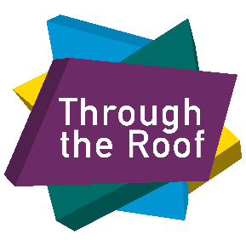 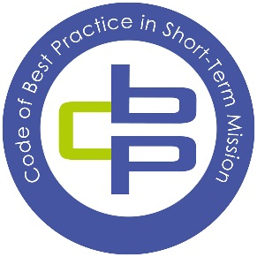

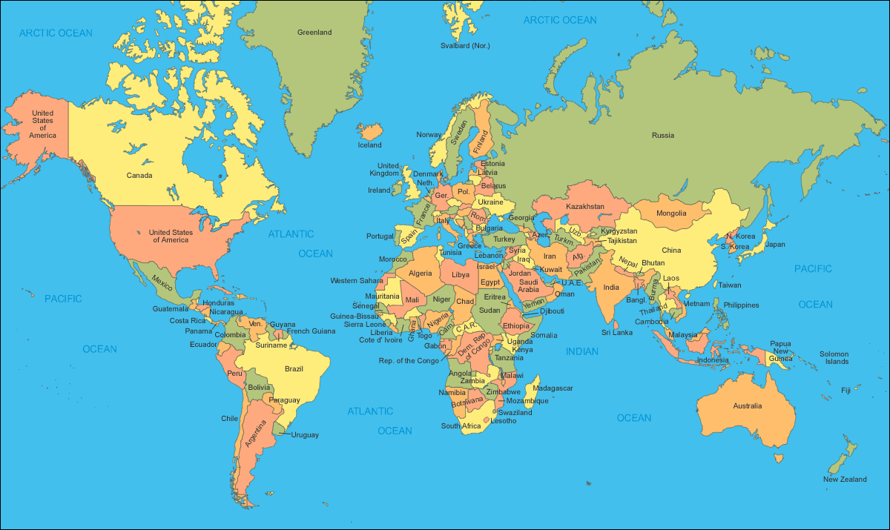**Opportunities for Through the Roof volunteers**

We are a registered UK charity No. 1087788. Registered Company No. 04201510.

Our office address: Our warehouse address:

Alpha House, Unit 1

Alpha Place, Fairfax Industrial Estate

Garth Road, Eastern Road

Morden, Aldershot,

SQ4 4TQ. GU12 4TU

**Welcome!**

We are very glad that you have contacted us and have enquired about our international programmes. Our heart’s desire is to serve our living true God and to serve him where he leads us. In this booklet we hope to explain all you need to know about Through the Roof, what different short term mission opportunities we offer.

“But you will receive power when the Holy Spirit comes upon you. You will be witnesses to me in Jerusalem, in all Judea and Samaria, and to the uttermost parts of the earth”. (Acts 1:8)

Shaun Burrows

International Mission Manager

**Through the Roof** is a Christian disability charity whose mission is to transform lives through disabled people. Our Vision is of a world where all people live interdependently, mutually giving and receiving, as God intended.

Through the Roof is a national, pan-disability, Christian ministry.  Since 1997 we have been seeking to ensure that the good news of the Christian message is accessible to everyone.

Through the Roof seeks to positively influence church and society. We act primarily as a catalyst for change, conveying a prophetic message where disabled people and others who have experience of disability – which we consider including those with mobility impairments, learning disabilities or mental health issues, sight loss and those in the Deaf community – are valued equally, fully included, and able to contribute their gifts and skills.

We want to work with and alongside disabled people as they become free to pursue all that life has to offer through the gift of a wheelchair. We want to see them connect to those around them, taking responsibility and discovering and operating according to God’s call on their lives.

The outcomes that we desire to achieve are ‘the ABC of disability inclusion’:

**Access:** For everyone to know Jesus, with disabled people fully welcomed into Christian life.

**Belonging:** For all to grow together as the family of God, flourishing in community with others.

**Commission:** For everyone to reflect Jesus, with disabled people making disciples, to the glory of God.

As a registered charity, we equip churches and organisations to fulfil the Biblical message of inclusion, as well as providing opportunities for Christians to get involved in mission with and alongside disabled people, nationally and internationally.



Why are we called Through the Roof?

The Bible tells a story of four men who took a paralyzed man to Jesus. They couldn’t get in the room and lowered him through the roof. It was the partnership between disabled and non-disabled people that made it possible for that man to meet Jesus. Through the Roof seeks to work in partnership with disabled and non-disabled people to make the Gospel accessible.

**Through the Roof International Mission opportunities**

Who do we partner with?

* Those who are already working in a developing country.
* Those who have a heart to serve disabled people or are currently serving in projects to do such.
* Those who understand that we cannot do anything, that all is achieved through the power of Jesus.
* Those that work with and through the local church.
* Those who can host a mission team.
* Those who can provide accommodation transport and organise logistics before a team arrives.

Why do we partner?

* We believe in country partners have far more experience knowledge and understanding of the local context. We come ready to learn from you.
* We believe that our partners will stay and continue the work long after we depart.
* We want to champion the amazing work that is being done by our partners.
* Our aim is to equip, enable and encourage our partners in areas they need support to continue their work.

The partnership will be based on:

* Mutual respect and trust.
* Open and transparent communications.
* Co-operation and consultation.
* A commitment to being positive and constructive.
* A willingness to work with and learn from others.
* A shared commitment to providing excellent services to the community.
* A desire to make the best use of resources.
* Equality.

[](http://www.google.co.uk/url?sa=i&rct=j&q=&esrc=s&source=images&cd=&cad=rja&uact=8&docid=r2L5QomG6FQ28M&tbnid=ouNU4vD0C3IMhM:&ved=0CAUQjRw&url=http://www.answersingenesis.org/articles/2010/10/03/am-promo&ei=66lDU97uLZKY0QW9yIHQDg&psig=AFQjCNH7ehySKYw_Pfos8FZcQqV4an6cWQ&ust=1397029573033796)

**WHEELS FOR THE WORLD**

Wheels for the World gives life-changing mobility aids to disabled people in developing nations. Volunteers in the UK refurbish disused wheelchairs; the chairs are then transported to where the need is greatest.

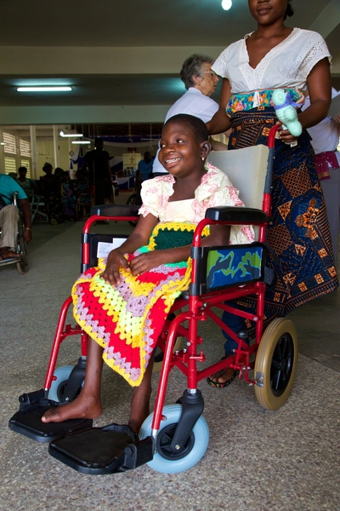The container of wheelchairs and other mobility aids is sent in advance of the arrival of our Wheels mission teams. A typical distribution usually lasts 8 – 12 days with the team Wheels Distribution is 10 days long. The accommodation is usually in a hotel with single or double room availability.

Our team will work alongside that of our partners to ensure that all the mobility aids are fitted according to international standards, and that the recipients and family members are instructed in the correct use and maintenance of their chair. We also offer recipients a Bible in their own language.

Our team members sometimes avail themselves to speak in local churches and community halls and spread the message of including disabled people into the life of the Church and the community.

**Our Wheels for the World (WFTW) teams normally consist of:**

* Four physiotherapists or occupational therapists, an administrator, two technicians to help you fit and distribute them usually over 10 days, normally a Wednesday to the following Saturday.
* They share the Gospel and give out Bibles to each wheelchair recipient.
* They give out training material for local church leaders and disabled people’s organisations.

**Benefits of a WFTW Trip:**

* One to one consultation for people with disabilities who are identified by our partner teams.
* Fitting and tailoring of equipment to each person.
* Giving Bible and prayer support.

**ROOFBREAKER EVENTS**

We believe the church is God’s vehicle for changing lives. Through this we believe the church needs to be equipped, empowered, and resourced to include disabled people fully in all aspects. The Bible says that each one of us has a part to play within the body of the church and that includes people with personal experience of disability.

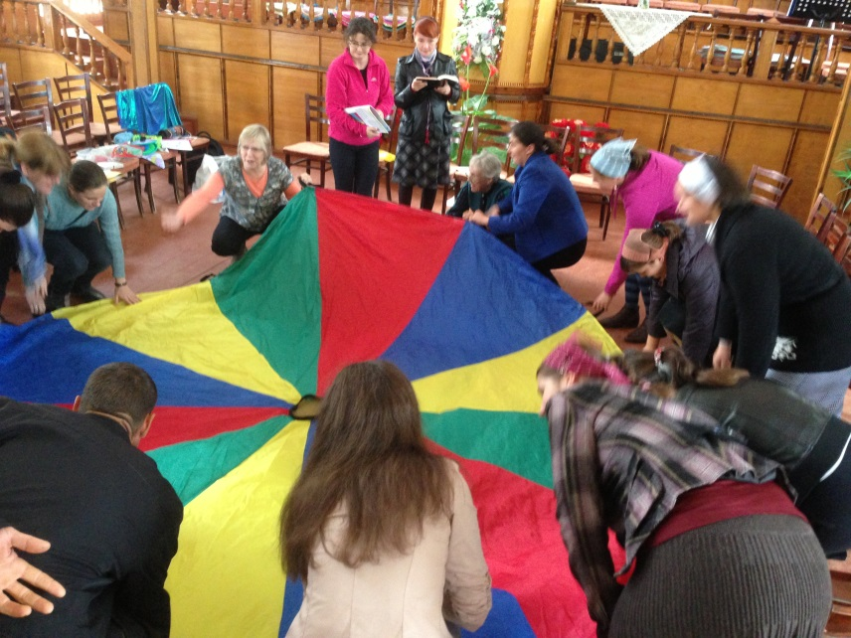We work alongside our partners’ teams to show Church and community leaders God’s view of disabled people.

We work alongside our partners’ teams to support disabled people and their families in their Church and community.

A typical Roofbreaker trip comprises of a team of 4 – 8 of our Through the Roof volunteers who have a Christian faith, and who will work alongside our partner teams to deliver training sessions. The trips are usually 7-10 days long.

**Benefits for a Roofbreaker event**

To equip local pastors and those working within the church with practical skills, understanding and confidence to think and act inclusively towards disabled people.

**Workshops:**

Based on the above the following criteria should be used to maximise the effectiveness of workshops:

Approximately 60 delegates in total at a training venue that has provision to accommodate 2 – 4 breakout groups for optional modules training.

**Leaders’ Events:**

We will work alongside our partners’ teams to host Leaders’ Events/ Seminars to impart the Biblical principles of inclusion to Church and community leaders and show God’s perspective of people with disabilities. If appropriate and necessary, the teaching will also deal with the cultural, ethnic, and spiritual barriers that prevent the inclusion of people with disabilities into the life of the Church and the community.

Suggestion:

* Maximum of 200 delegates in total.
* Training venue to have the provision to accommodate breakout groups of 5-10 leaders per group.

**Our volunteers are responsible for:**

* Booking and paying for their own flights
* Paying a team fee that covers their in-country costs.

**Our partners are responsible for:**

* Finding a place for the team to stay.
* Organising local transport for the team.
* Identifying local churches to empower, enable and equip.
* Providing one day sightseeing in local area.
* Providing interpreters.
* Identifying event venues.
* Caring for all aspects of the team when they are in country.

**What now?**

**If you are interested in partnering with Through the Roof please contact the International Missions Manager Shaun Burrows at** [**Shaun@throughtheroof.org**](mailto:Shaun@throughtheroof.org)