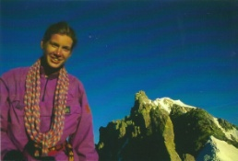
For those of you who don’t know.....
Many years ago I was quite fit and used to spend much time climbing (generally by one of the most awkward routes) to the top of mountains and cliffs.
One day in the Alps I got a stomach bug and it completely floored me and after a year I was diagnosed with ME/CFS. Several years of debilitating illness followed, being housebound / bed ridden / a drug treatment in Belgium / learning to walk again / regaining strength.
Now 17 years after I first fell ill I finally feel well enough to challenge myself. I have decided that as a celebration of wellness I am going to walk The Cheviot Challenge. It is a walk of about 24 miles in the Cheviots on the 25th August. I can’t adequately thank all those who supported me when I was ill or who have walked with me as I have recovered, but I would like to ask you all to celebrate with me so that I can use it as an opportunity to help people less fortunate than myself by asking you to sponsor my walk and giving money to Wheels for the World.
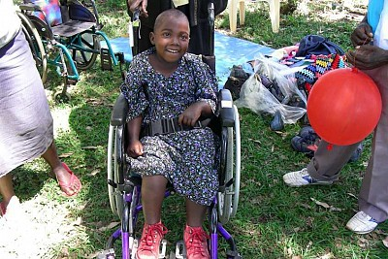
The World Health Organisation report that there are 20 – 30 million disabled people who need wheelchairs. Most of these have no ability to buy one. Wheels for the World takes used NHS wheelchairs to HMP Parkhurst where prisoners refurbish them. They are then taken mainly to Africa to be distributed. Thousands of wheelchairs which would otherwise have ended up in UK landfill have given people a chance of a new life. You can see what they are doing at www.throughtheroof.org/ourprogramme/wheels-for-the-world
So please celebrate with me, give generously to change a life today and give to Wheels for the World.
http://www.justgiving.com/Charlotte-Lobb

